The Art of Annotating Text
Annotate: verb [-tating, -tated] to add critical or explanatory notes to a written work. Interaction with a text.
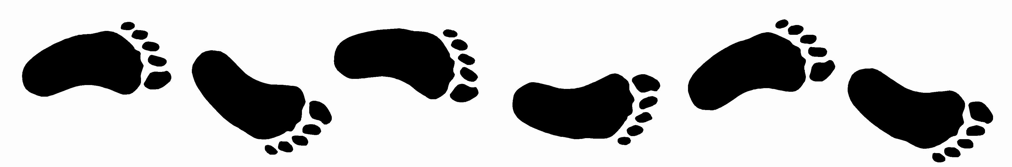 Annotation leaves a trail of your thinking throughout the text. It helps to have a conversation with the text!
Why annotate? Serious readers take notes of some kind when they are carefully considering a text. Annotating a novel or text helps improve depth of thought as well as allows you to remember the text better. This does not have to be difficult but is personally and academically useful; a great study tool- making you work smarter, not harder. When you come back to the novel all the information is together and inseparable, with notes close to the text for easier understanding and fewer pieces to keep organized.
Methods & Suggestions
- Use your margins! Write in the margins if you own your book. Sticky notes are good and can also be easily removed if you do not own your book. Write on the sticky notes.

- Remember that some pages will be marked up more than others. Do not stress about over or under annotating, but be sure to show enough of a trail of thinking and insights. Focus on key information and do not over highlight or underline!

- Use keys or symbols that you understand what you mean. For example, * , [ ], ?, , etc.

- Be active (connections, questions, observations), not passive (does not involve much thought or comprehension).

What to Look For
- Figurative Language (similes, alliteration, metaphors, imagery, simile, hyperbole, etc.)

- Main Points, Messages, & Themes

- Personal Thoughts and Reactions

The Art of Annotating Text
Below are some examples from students’ annotations. You will notice different levels of markings. Some of your pages will have many thoughts and observations, some may not. Every single page does not needs to be riddled with markings, but when you have thoughts, opinions, or an important scene of the book is occurring, you will want to mark it up! Remember – leave a trail of thinking and analysis.
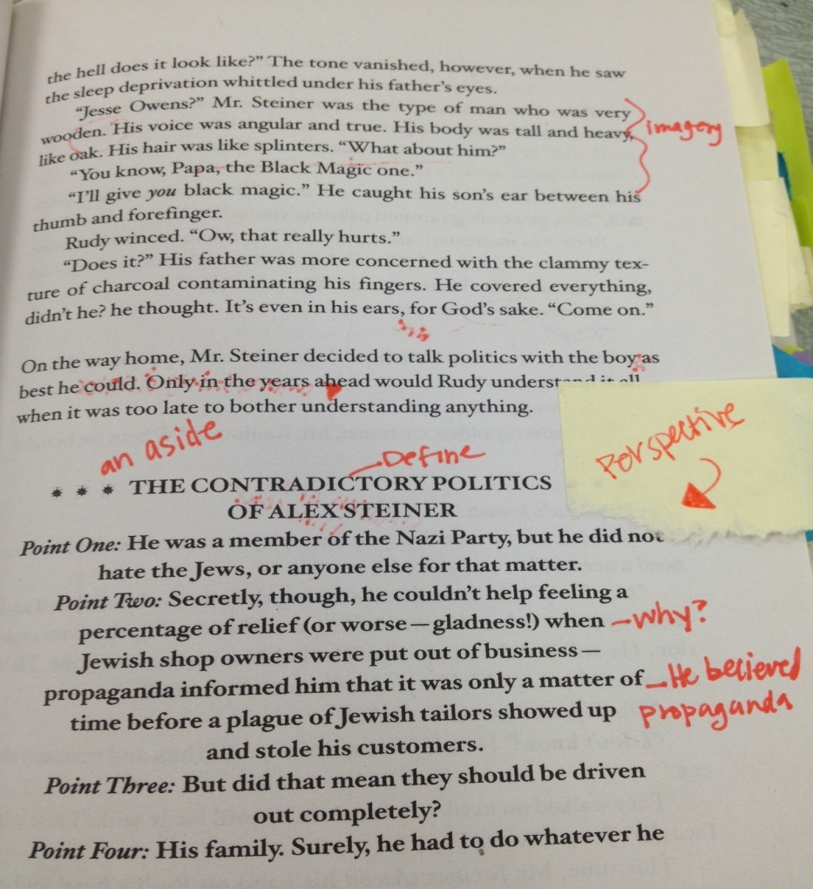

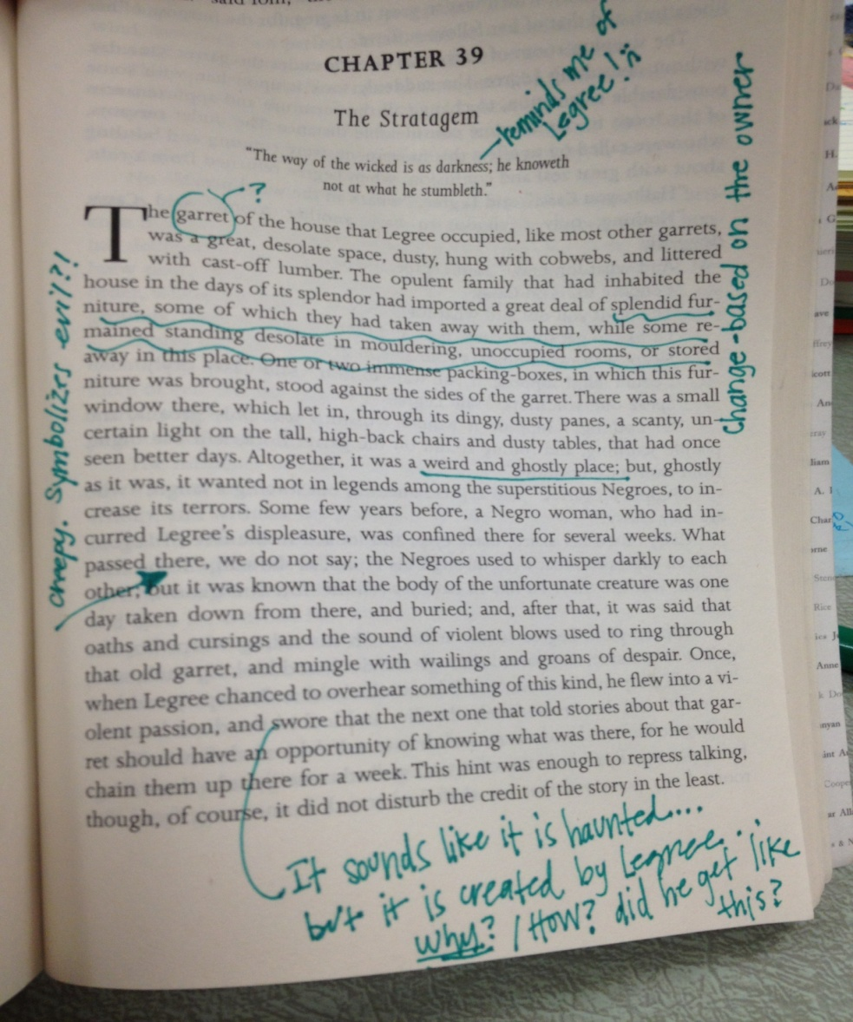

Below is a more intense version – remember, do not feel that each page should look like this, but there are many interesting observations and suggestions within the marked up poem.
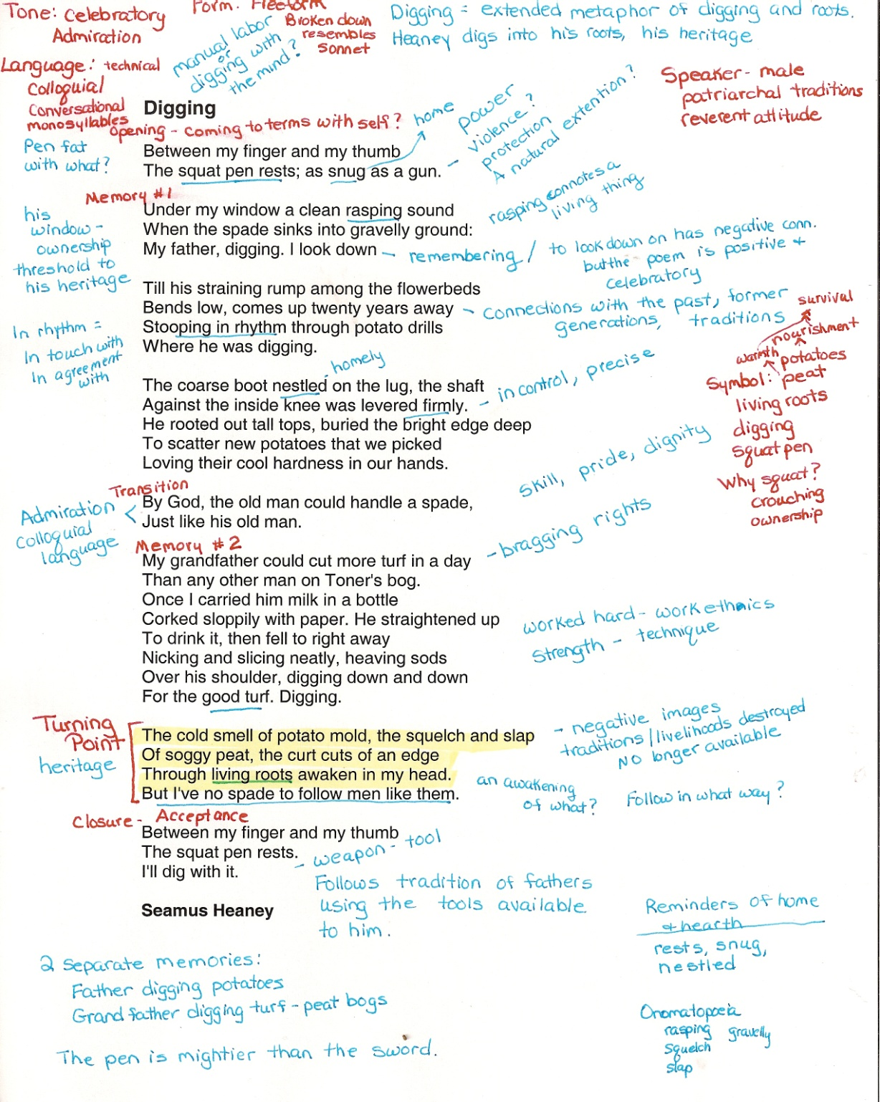
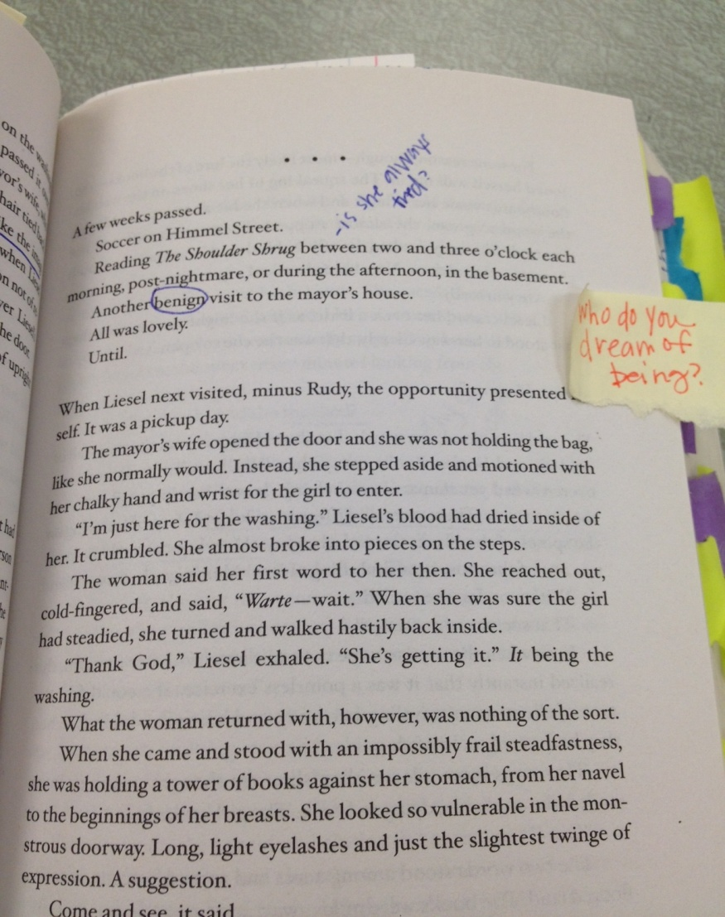
Other suggestions on what to mark up: